IFT 166 Introduction to Internet Networking
Lab 3
Packet Tracer Introduction and Forwarding IP Datagrams

- Packet Tracer is a network simulator developed Cisco Systems.
- ‘Simulator’ – simulates network devices and its environment.
- Packet Tracer supports a lot of protocols.
- Protocols in Packet Tracer are coded to work and behave in the same way as they would on read hardware.

Purpose: The purpose of this lab is to become familiar with building topologies in Packet Tracer.

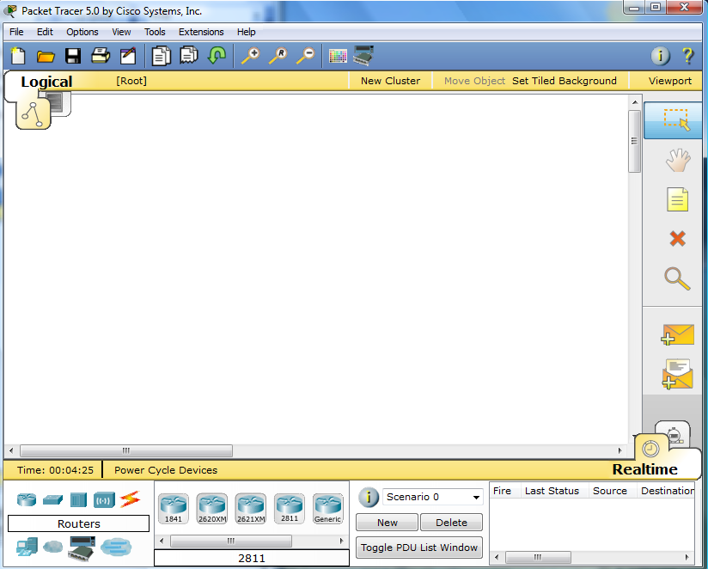

Lab 3 Deliverables
Provide 2 screenshots of your work as indicated on the lab & answer any questions that may be asked.
In these screenshots, show proof that it is your work e.g. use appropriate names on the nodes.

Packet Tracer Installation
- Obtain a copy of the Packet Tracer software the folder link on Blackboard).
- Install the software onto your portable hard drive (accept the default settings)
- Once installed, you should have a shortcut icon on your desktop….now double click the icon to open the program
- Upon opening, you will see the opening screen to Packet Tracer.



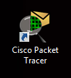

Packet Tracer Overview
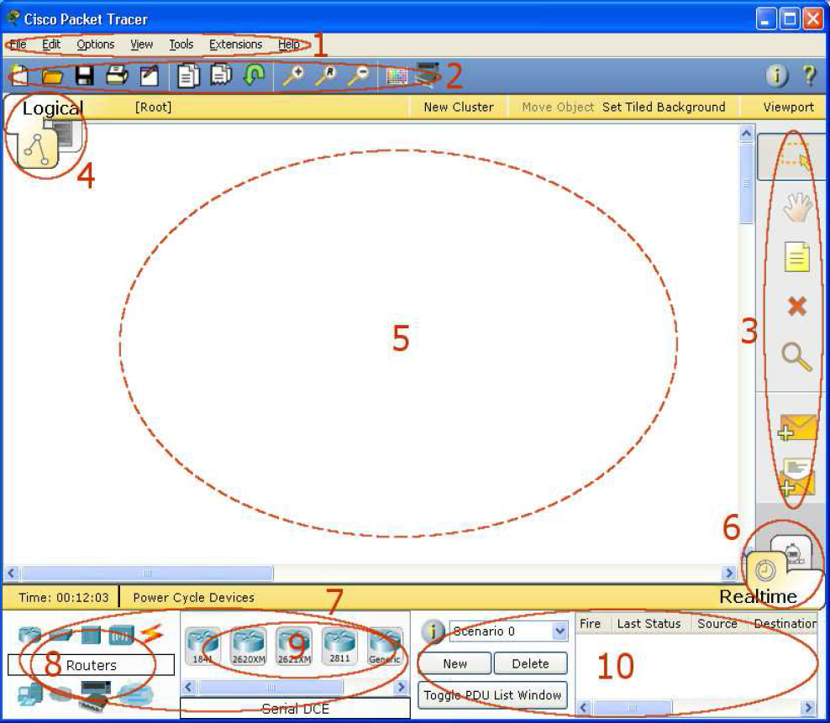
- Menu Bar: common menu found in most software e.g. open, save, print
- Main Toolbar: shortcut icons to menu options e.g. open, save, print and networking information button for entering a description for the current network.
- Commons Toolbar: commonly used workspace tools for manipulating topologies e.g. select, delete, move

- Logical/Physical workspace tabs: toggle between tabs

- Workspace: area where topologies are created and simulations are displayed

- Realtime/Simulation tabs: toggle between tabs

- Network component box: choose devices and connections to put into the workspace. It contains the Device-Type Selection Box and the Device-Specific Selection Box.
- Device Type selection box: type of devices and connections available in Packet Tracer. The Device-Specific Selection Box will change depending on which type of device you choose.
- Device-Specific Selection Box: choose specifically which devices you want to put in your network and which connections to make.
- User Created Packet Window: users create customized packets to test topologies and the results are displayed as a list

Create a Simple Topology

- Start off with a clear workspace.
- On the device type selection box, click on end devices and then drag and drop a generic PC icon and a generic laptop onto the workspace from the device specific selection box (as below)

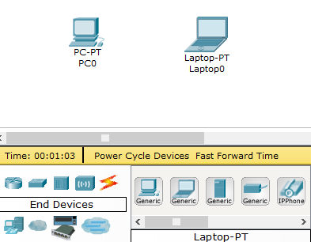

- Click the connections icon in the device type selection box and then click on copper cross over cable.

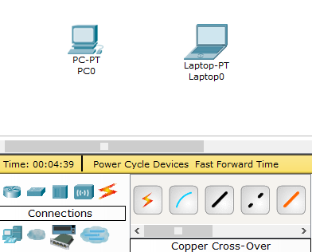

- With the copper cross over cable selected, click on PC then select FastEthernet and then click on the Laptop and select FastEthernet

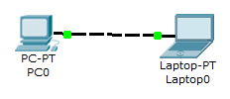
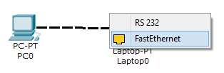
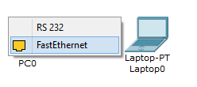

- With the physical connection established, click on the PC, select Desktop and click IP configuration

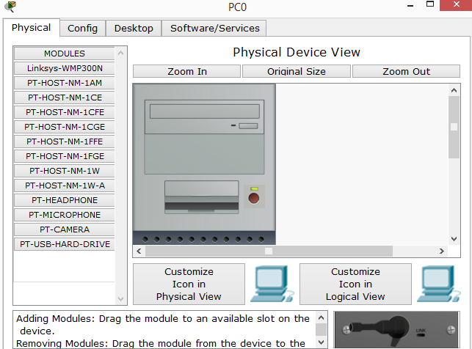
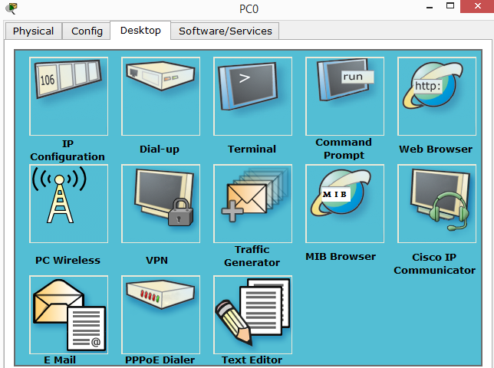

- Enter the information as in the image below. We do not need to enter the default gateway or the DNS server information as there are only 2 devices in this network.

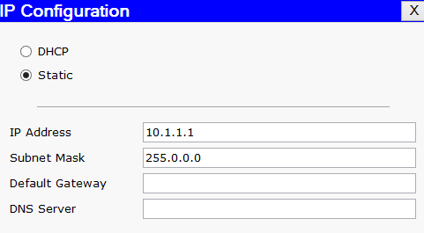

- Repeat steps 5 and 6 for the laptop (IP: 10.1.1.2 SM: 255.0.0.0)
- On the PC, open the command prompt and will attempt to see if we can contact the laptop through the ping command.

- In the command window type: ping 10.1.1.2 and you should see the following
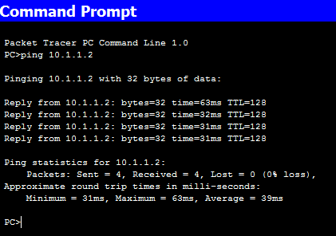

- Now we will add in a switch to our topology (as shown below)
- You will need to remove the cable/link connecting the PC to the laptop using the delete tool on the commons toolbar.
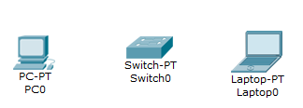

- We will now connect the PC to the switch and the laptop to the switch using 2 separate copper straight through cables. Same procedure are before, click the cable, and click PC and then FastEthernet and same on the switch.

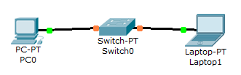
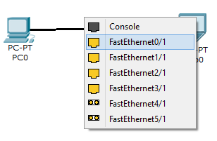

- Initially the link lights on the switch are orange (as above) but will soon turn green.

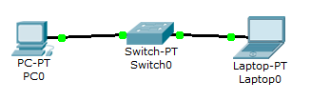


- With the switch connected on both sides, check for connectivity again using the ping command.

Put your Screenshot 1 in this box

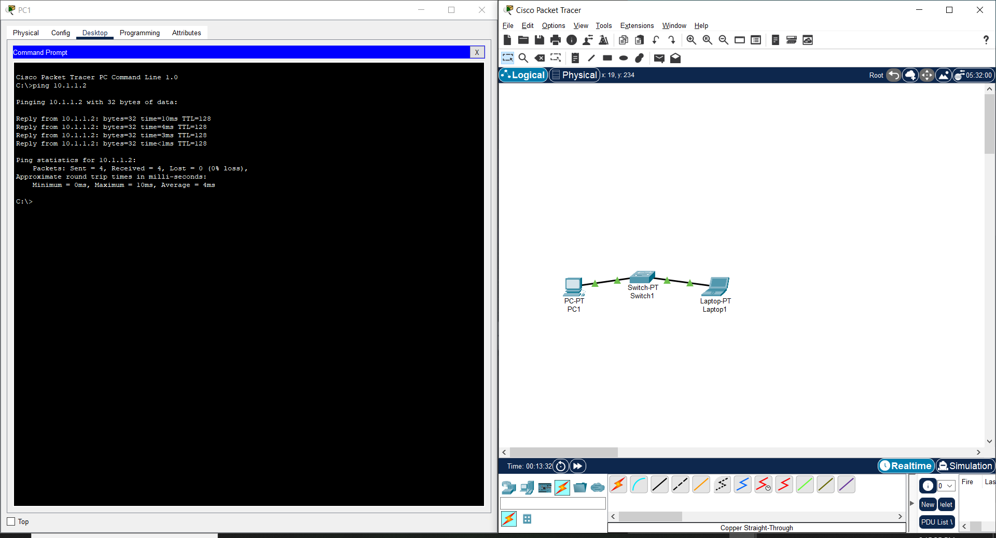

Sending Simple PDU’s
- Once a topology has been created, connectivity can be tested between devices by using either simple or complex PDU’s.
- Pinging devices from the command line interface can do the same thing but PDU is quicker for larger topologies.
- Simple PDU is a graphical way to send pings.
- Simple PDU just makes a single ping attempt. Whereas ping command send 4 rounds.

- Setup the following topology
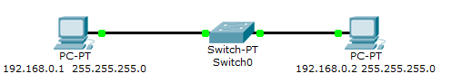

- Use the standard ping command to verify connection between the PCs

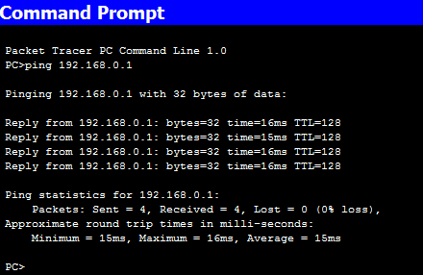

- From the common toolbar, click the closed envelop or shortcut key P (Add Simple PDU).
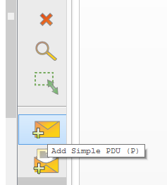

- The pointer changes to an envelope symbol. Click on PC0 and then on PC1. After clicking on PC0, an envelope will appear on PC0
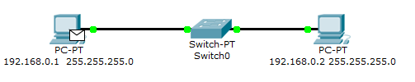

- After clicking PC1, look at the user created packet box which will show “status = successful”. You can see the source and destination of the packets.

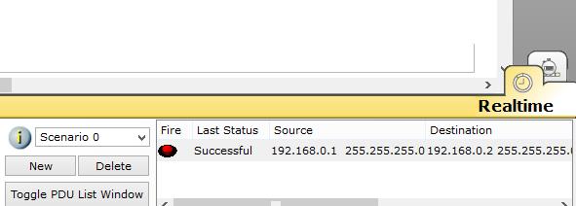

- Now change the IP address of PC1 to 192.168.1.1 and redo the Add Simple PDU
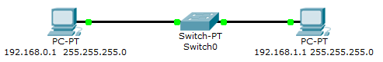

- In the user created packet box, it should now say ‘Failed’

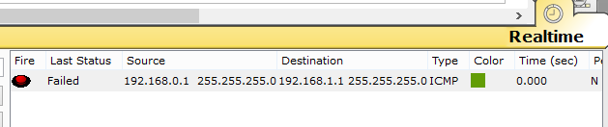

Any idea why the Add Simple PDU failed?

- So far, all of what we did was in Realtime mode. The only indication of traffic was the link status blinking green.

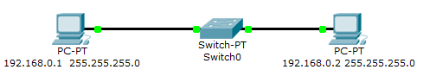
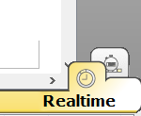

- By using simulation mode, you can see the packets flowing from one node to another. Click the capture/forward button to move the packet along the route.
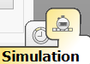
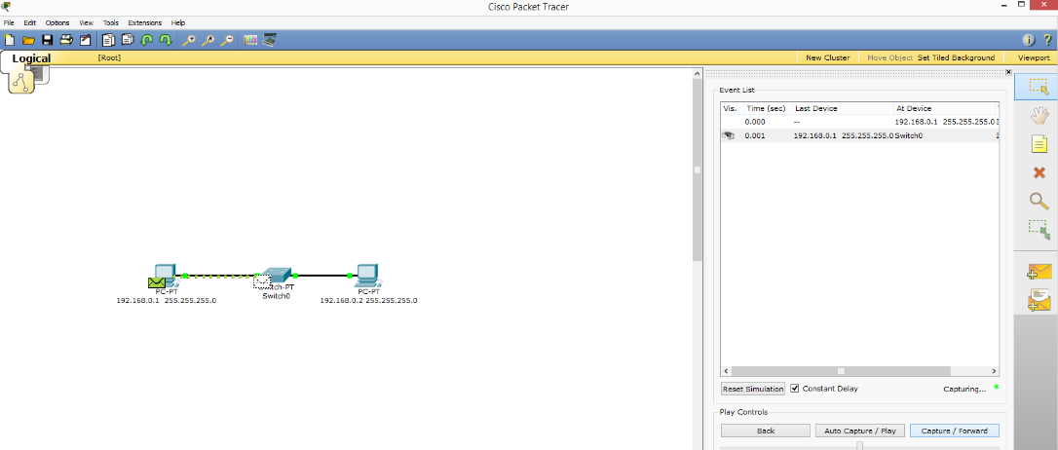

Screenshot 2

Put you Screenshot 2 in this box
